- Download a small dataset of IPL cricket player stats (e.g., runs, wickets, matches, strike rate) and apply StandardScaler from scikit-learn to scale all numeric features. Save the scaled data to a new CSV file named ipl_scaled.csv.
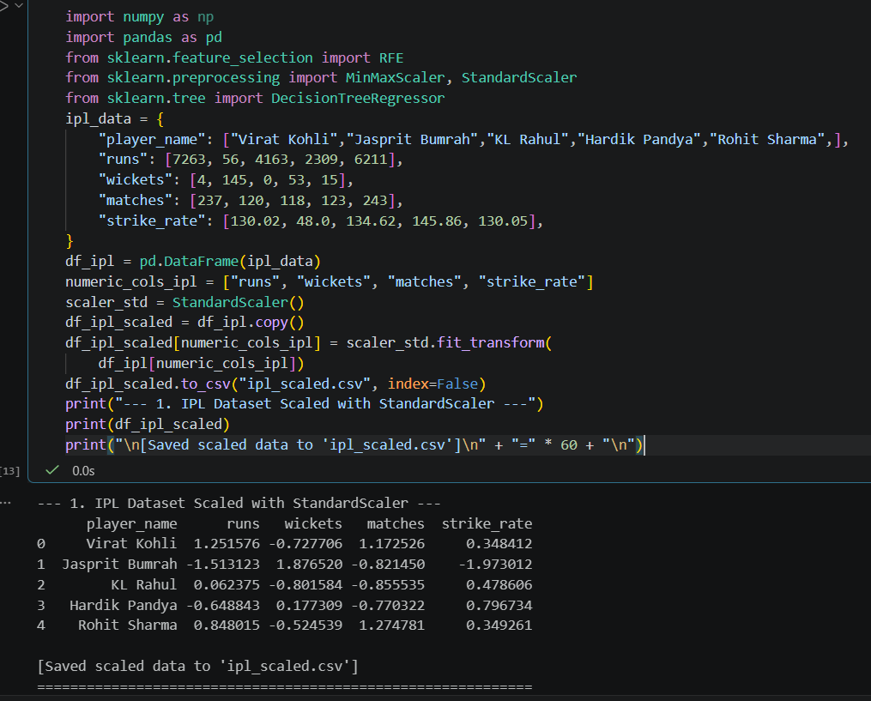

- Using a dataset of Flipkart product ratings (features: price, rating, number of reviews, discount), apply MinMaxScaler so that all features are scaled between 0 and 1. Print the minimum and maximum value for each column before and after scaling. Use pandas to load the data and scikit-learn's MinMaxScaler for scaling.

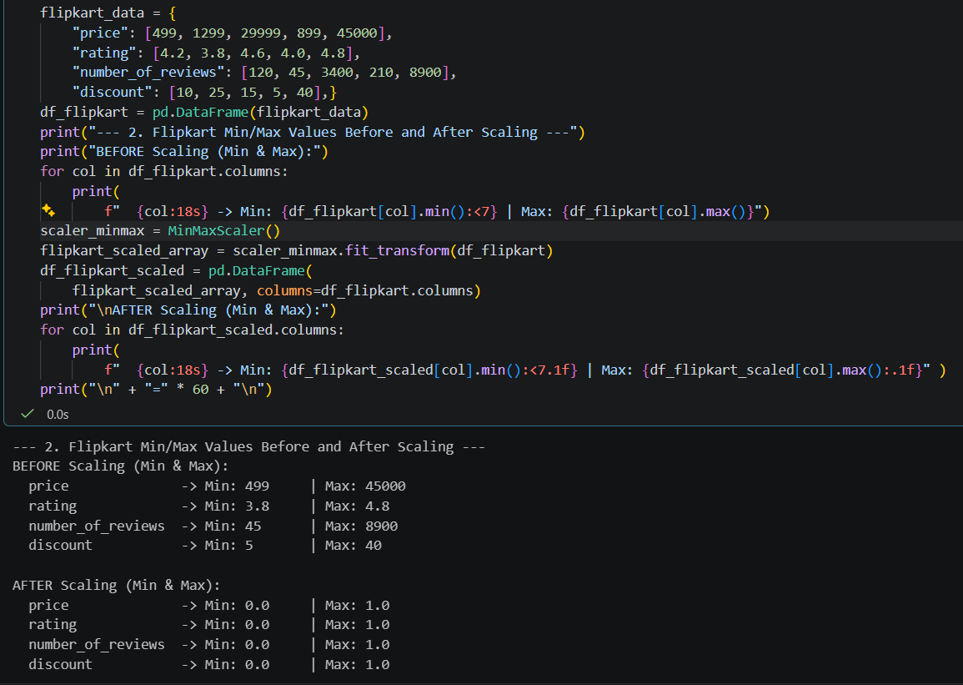

- Given a Spotify songs dataset (features: danceability, energy, tempo, popularity), use correlation analysis to select the top 2 features most related to 'popularity'. List the selected features and explain your choice in one line each.

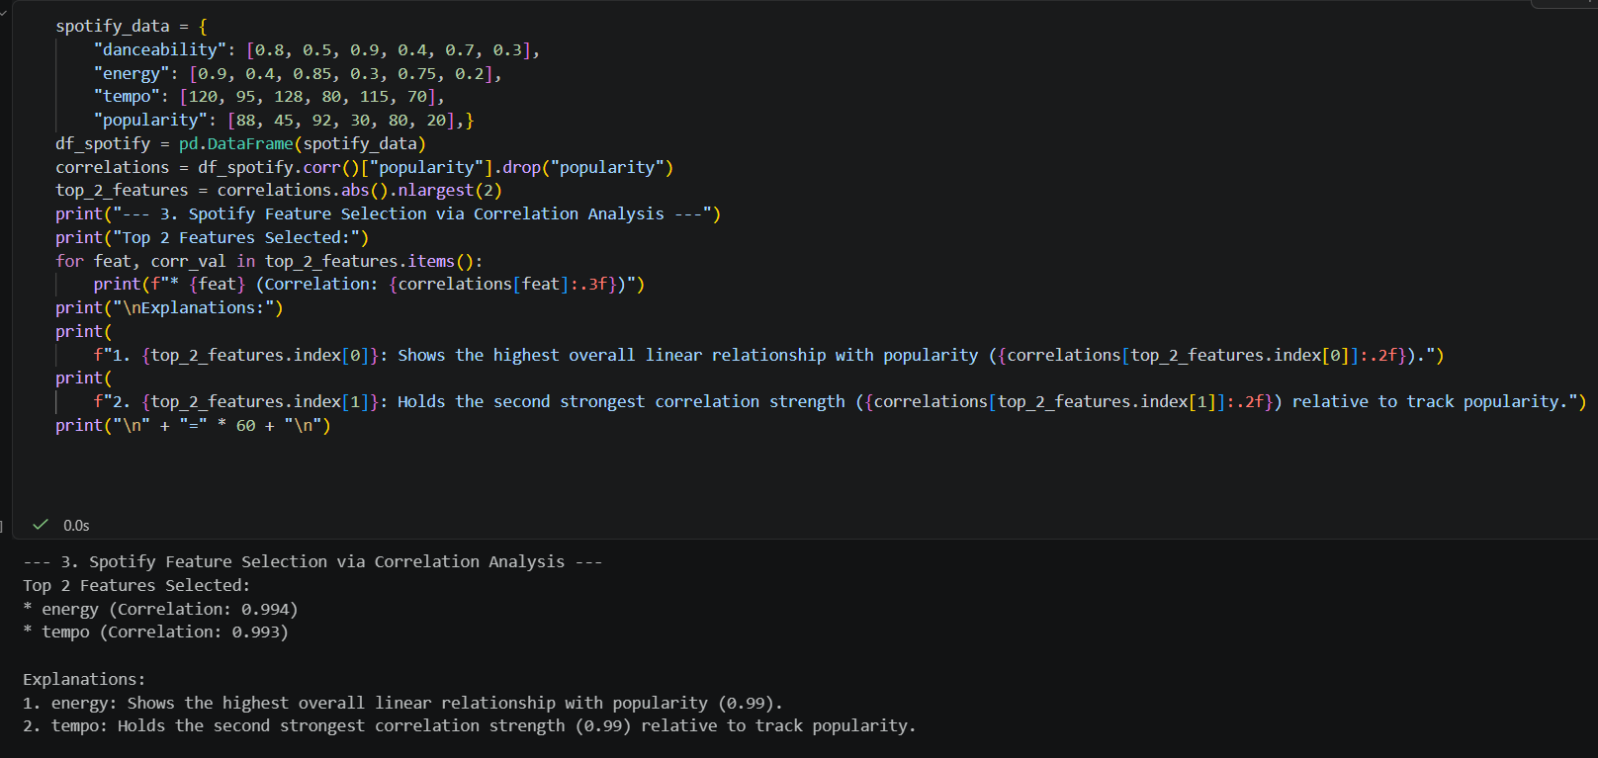

- Take a Zomato restaurant dataset and use scikit-learn's RFE (Recursive Feature Elimination) with a DecisionTreeRegressor to select the 3 most important features for predicting 'average cost for two'. List the selected features and the RFE ranking.
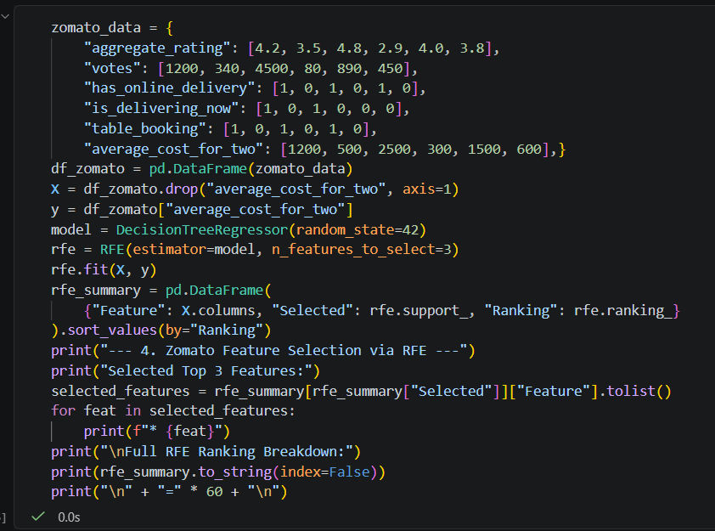
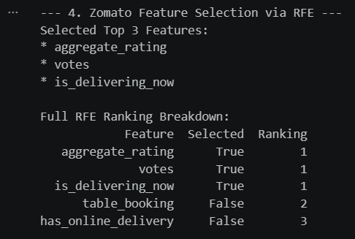

- Given a BookMyShow movie ratings dataset, detect outliers in the 'user ratings' column using the IQR method. Remove the outliers and display how many rows were dropped.Calculate Q1, Q3, and IQR; filter out rows outside [Q1 - 1.5*IQR, Q3 + 1.5*IQR].
